TUGAS PRAKTIKUM

“ARRAY MERGE”

* PROBLEM1

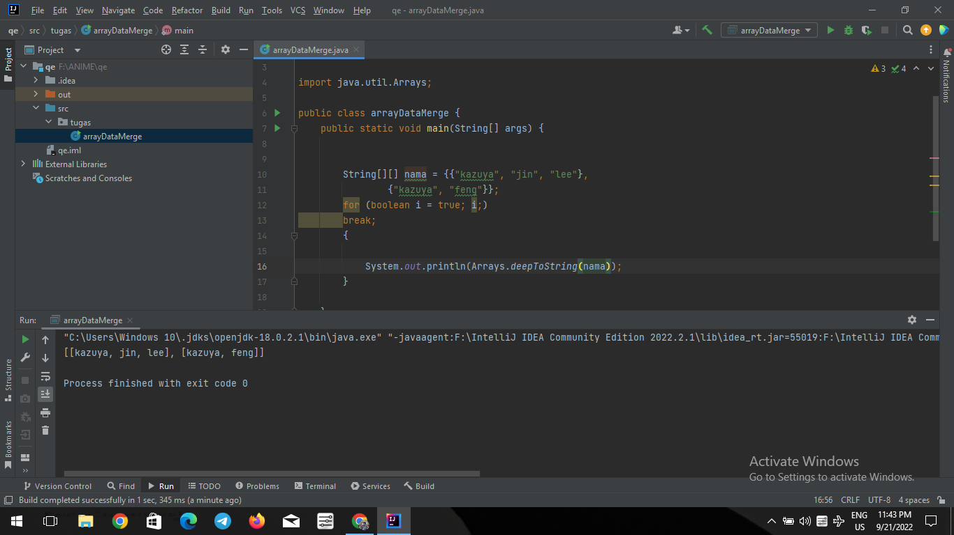

* PROBLEM 2

